Getting to Know: Keely Latopolski
Written by: Maureen Flint (Ph.D. student in Educational Research)

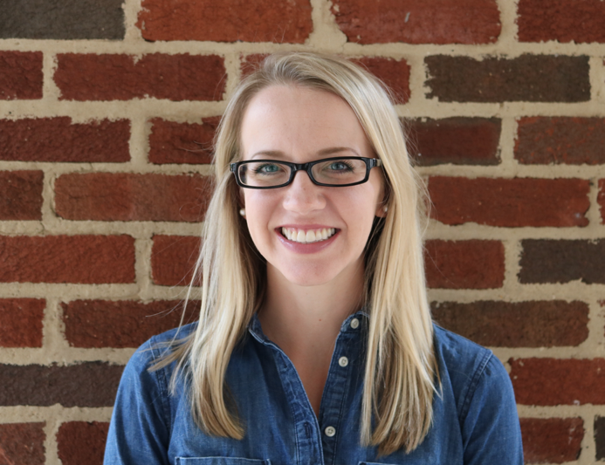
Keely Latopolski is a doctoral student in Higher Education Administration and is working towards the Qualitative Research Certificate. Keely works on campus as an Academic Advisor with Culverhouse College of Commerce.
Keely, tell me a little about yourself and your research…
So, I'm in the fourth year of my PhD studies in Higher Education Administration and I have completed the College Teaching Certificate. I’m also in the process of finishing the coursework for the Qual Certificate. I'm interested in studying student's experiences of mattering, and specifically right now I'm looking at academic advising settings. I am an academic advisor on campus, and I love my job and I love what I do so I kind of want to explore that area of student’s experiences.
How do you see your role as an academic advisor playing into or interacting with your qualitative studies?
I was thinking recently that I don't know if it just happened or if the qualitative coursework kind of fed into this… but now I feel like every time I meet with a student it's like a qualitative interview. So, the course scheduling part of advising -- that's the last thing I care about -- that's the last thing I talk about, we spend like the last ten minutes of our meeting focused on that. The time before that is all focused on the student and me asking them questions about what's going on in their lives and their experiences. What they're thinking and how that all kind of comes together and into their academics. You know, whether that's having a positive effect or a negative impact on them or if it's not at all a part of what's happening in the classroom. So I feel like that for me is how I link the qual coursework into what I do as an advisor, every day just practicing those interview skills and techniques.
Can you talk specifically about an interview skill that you’ve applied?
I took an interview course last semester with Dr. Shelton, who is a rockstar -- I just think the world of her. So early on in Qual I we talked about open ended questions, and that's been really beneficial, but specifically in the interview class, talking about different types of interviews has been useful. For example, just letting students explain their perspectives and experiences through questions like "tell me about an experience when this happened" or using different lenses to frame questions and to really contextualize the setting that we're in. How student’s experiences and time outside of the classroom is really shaping their whole experience at UA. You know as I’m thinking about it it's not only that interview class but other courses like Critical Geography and Critical Race Theory -- they all play into the frameworks that I use when I work with students, and especially how I relate to students and their experiences. Especially some of the notions of power and privilege and how students are living those realities.
You mentioned that you're in Higher Ed Administration and you've finished the College Teaching Certificate – how have qualitative courses interwoven or played into those courses?
I think they've afforded me a broader perspective... and really enlightened the work that I've been able to bring to my Higher Ed Courses. You know the first class that I took coming back to grad school was Critical Race Theory and it was very challenging -- First, it was coming back to grad school, and then taking a critical class in foundations. I was hooked immediately into the critical notion of what means to look at those structures of power and how it can expose injustices and different marginalized populations. So, that’s what I was initially drawn to, and then taking the Critical Geography class expounded on that - looking at power and privilege in terms of space, that's not something I would have received in the Higher Ed program just by virtue of those classes. I think it's important that we talk about those concepts in higher education and so [because of the qual classes] I could be that perspective in the classroom, or have that lens in some of my papers. That has really added a lot of value to the work that I do. I think it's definitely broadened my perspective and it's changed how I look at the Higher Ed literature and it's changed how I understand what we're studying in class too.
Can you give an example of how your perspective on Higher Ed literature has changed?
Let me think... you know it informs everything, so I'm really glad that I took those classes early on. For example, even organizational change in Higher Education. I know that in Higher Ed it takes a long time to enact change, but I think understanding some of the structures in place and how it's more than the organization of the institution, and there are other power structures at play there. And I think even in terms of student development, understanding how these landmark studies that we always reference and look to are conducted and who they are studying. As well as when we look at different identity theories, how are we understanding them, and through what lens, and how those identities are being represented in literature… I think it all really changes your perspective… it's not something you can unlearn, like it's a pair of glasses you always have to wear. It’s ever present in your mind, like a switch has been turned on.
How have you seen your own theoretical practice or articulation change or develop through taking Qual courses?
I was just writing about this in an analytic memo for Qual III; that if I were to be given the same assignment in Qual I was given today it would look completely different, it would feel different, it would read different. Qual classes really challenged me to be thorough and critical and thoughtful in every aspect of my practice. So, I think it's taught me to really be more thoughtful and mindful in the work that I do, and it's given me more tools to work with as a result. So, I'm interested in student’s experiences and their mattering and I think without delving more into the qual classes, I would not have the tools to further explore [those experiences] as I'm able to now had I not taken the qual classes in the beginning.
How have methods courses enabled the process of your dissertation?
I was walking over here and thinking about that question… I don't know how I would be able to do my dissertation without the qual classes. I think now that I'm at the stage (the frightening stage) of preparing a proposal - you do all of this work and while all of your coursework is very much needed to contextualize what you’re doing, it all comes down to the methods. The methods are what I think you're really probed on or questioned on, and so I don't think I would feel as… I don't know how I would do it without the qual classes to be honest. I don’t know if that’s a security thing for me, but I just I have no idea how I would be [without them] - not that I feel like 100% prepared, because I have a lot of work to do, but I feel in a much better place having the background of Qual I, Qual II, Critical Geography, the interview class, like I feel like I have a better understanding of methods and methodology and what that all means going into the dissertation. So, like I said while it's all important coming together, in terms of going into proposal, methods are key.
What practices have you adopted that have helped be successful as you move through your course work?
For me, learning how I best work is a process that has taken until now, especially working on the proposal. I think the assignment we first had in Qual III this semester about our writing rituals really forced me to look at that, and I know I work best now in long stretches of time. Things don't come to me immediately, so it takes me a while to process and think through things. That might mean reading for a while or typing and erasing for a while, and it's only after when I get into like the four-hour mark that I'm hitting my stride. And that sounds terrible but that's what I've learned about myself, and I think learning that earlier is more beneficial. And for me, when you work and take classes, I think it's important to take time off to dedicate to your school work, that's something I wish I had done more of in the past because when I don't do that it's like - you have to write when you can, and you write when you have to, and that's not the best, and because of that you have to sacrifice other things that happen. So I think being able to set aside concrete days that you can work on projects or read, that's something I wish I would have done that I think would be beneficial.
What were some challenges you've experienced completing the Qual Certificate?
I would say one of the things I think people should be aware of is the order of the classes that are offered or the way that they're offered I guess. So, (right now) Qual III is only offered in the fall so I think that's important to know so if you want to build up to that, and not have to wait a semester or something.
One other thing I would say is it’s not easy, and I'm challenged every time I have a conversation with a qual faculty member -- but in the best way, and so I don't want to say it's challenging and dismay people, because it is challenging, but like I said in the best way. Because it challenges you to grow as not only a student and a researcher but as a person. And that's invaluable. I think what's been challenging is like I don't get it. You know what I mean? I don't understand it all the time, and I was in Qual I and I thought you know, this is it, this is going to click, and I'm going to get it, and this is going to be me, and I'm going to do qual work… and that did not happen! And I waited week after week for that to happen, and I kept telling myself like this is the week it's going to happen, and it didn't. So, that's a challenge but knowing that that it doesn't immediately click makes it okay. You know, even in Qual III, I'm hanging on as best I can. And in Critical Geography, I was following along as best I could, but you know there are certain concepts that now looking back I can say oh right, now I can wrap my head around that, but sometimes in the moment and in class it was difficult and challenging. When you feel like I don't get it, and that you’re the only one who is floundering -- when you're not. So, it’s challenging but in a good way. It confronts some of who you are, your person. That being said, I think it's exciting too, and it's fun. And I think I have said this to each of the qual faculty members, but I love them and I think they just do such a fantastic job of supporting and encouraging students and they know that I'm hanging on and I might not be with them every step of the way but I'm there, I’m trying.
Is there anything that you would like to add that we haven't talked about?
What I really like about the Qual Certificate and what I have enjoyed beyond the faculty (because I would sing their praises all day) are two things: One is that any time you can take a special topics class, which is generally a class that the faculty are interested in and an expert in, take them. I think it's so worthwhile. Those have been the classes for me that I think I've been challenged the most and pushed the most and grown the most in. I think those have been my areas of interest and passion and that's really been beneficial for me. And then, part of my reason in pursuing the Qual Certificate, when I was in the midst of the Higher Ed Coursework, two faculty who I was close with were on sabbatical, one faculty who I was close with was leaving, so the qual faculty so welcomed me, and like it was a home for me. So, they are great.

