Getting to Know: Caitlin Byrne
Written by: Maureen A. Flint (Ph.D. student in Educational Research)

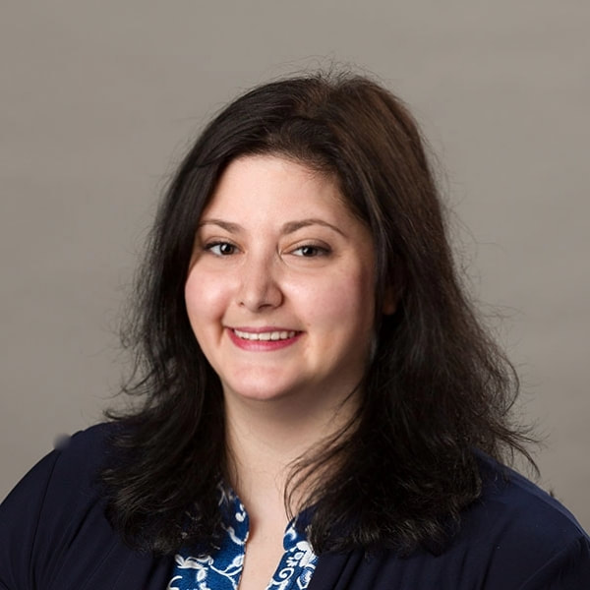
Dr. Caitlin Byrne received her doctorate in Educational Research from the University of Alabama (2018) with a specialization in Qualitative Inquiry. She currently a tenure-track Assistant Professor at Weber State University.
Would you share a little bit about your current position?
I am currently working as an Assistant Professor of Research Methods in the Teacher Education department at Weber State University, which is located in Ogden, Utah. This semester, I am teaching two graduate-level courses, including Educational Research and Instructional Strategies. Next semester, I will also teach a course in Planning, Instruction, and Assessment. In addition to teaching, I am also a practicum supervisor and a student teaching supervisor. It’s a lot at times, but it’s wonderful.
What drew you into qualitative methods?
For me, qualitative research is about people and about possibilities. It’s about recognizing that there is more than one way of seeing the world, and it’s about being okay with the uncertainty that accompanies that recognition. These ideas resonated with me. Further, I looked at the type of work that was being done by UA’s qualitative faculty and by the scholars whose work I read in UA’s qualitative courses. I liked the kinds of research problems these works addressed and the approaches used to address these problems. I guess for me, I felt at home with Qual. I still do!

How would you describe your involvement in the qualitative program?
Throughout the course of my five years of doctoral study, the qualitative program has developed tremendously at UA. There is a real sense of community now in the qualitative program that is quite wonderful. As a doc student, I tried to stay involved as much as possible. I participated in qual community events, such as brown bags, meet and greets, and social events. Participating in these things helped me to feel connected to other qualitative scholars at UA. It also helped to pull me out of the dissertation-isolation bubble that is all too easy to get lost in during that final year or two of one’s doc program.
Tell me more about how your theory and qualitative coursework influenced you through your dissertation and in your current position.
Oh gosh. Where to start? As someone who admittedly started the program questioning why “all this theory stuff” was necessary… my tune has certainly changed. In Qual 3, Dr. Kuntz had us read Jackson & Mazzei’s text Thinking with Theory. I had a hard time thinking with theory during that class. Let me tell you… during my dissertation? I thought with theory. Around theory. Through theory. Beyond theory. It was basically, one long journey with theory. For my dissertation, I did Foucauldian discourse analysis. Doing so meant that I not only needed to understand Foucauldian theory, but I had to interpret and apply Foucault through all aspects of my study. Given my prior reticence towards theory, and my awareness that Dr. Kuntz (one of my committee members), was a Foucauldian scholar, this was a challenging endeavor, indeed. I will say that all of my coursework in theory has helped me tremendously as I teach my research methods course at Weber State. For one thing, I aspire to be as patient with my students as they learn about paradigms, ontology, and epistemology, as my professors were with me when I learned of these things.
How have you seen yourself develop in your theoretical practice and articulation?
I feel that I truly began to understand the importance of theory and the way that it informs my work as I engaged with Foucault for the prolonged period from comps through the completion of my dissertation. Prior to the dissertation process, it was almost like speed-dating with various theories/theorists in my coursework. I got to know a bit about what was out there, but I didn’t have to really invest in anything. In contrast, the dissertation process was like entering into a long-term relationship with a particular theorist. I was fully invested in understanding the theory/theories, and I constantly negotiated my relationship with those theories as my work progressed. In the end, because I put in that work, there was a sense of harmony that existed between theory, my research, and my articulation of that work in my dissertation. The struggles and stresses of getting to that point are something that I know I’ll face again and again in my scholarly work, and I’m ready for that challenge.
What advice or suggestions do you have for current or future doctoral students?
Build your CV throughout your studies. Actively seek out opportunities to publish your work. Get involved in professional organizations. Take on leadership roles in your program, department, or at the university level. Present at conferences. Find out what the kinds of jobs you want are looking for, and position yourself to be an ideal candidate for those jobs by building your CV as you go. That said, take care of yourself. Allow yourself to be human. It’s easy to get caught up in all that there is to do. If you don’t set aside time for yourself to decompress, spend time with loved ones, and tend to your own well-being, then that will take a toll on you and your work. Finding this balance is key.
How have you used or applied what you’ve learned in qualitative courses to your current position?
I teach a course on research methods and I draw from my qualitative coursework all the time! During the second week of my course, I taught my students about research paradigms, ontology, and epistemology. When I thought back to how long it took me to really understand these concepts, I was a bit overwhelmed at the prospect of having to essentially cover the topic in one week! I went through my notes, handouts, and texts from the qualitative courses that I took at UA, and drew heavily from these in my lesson. Having these resources took a great deal of stress out of my planning, and ultimately helped me to teach a successful lesson. Throughout the semester, I have continued to draw from my qualitative course materials as I’ve covered topics like ethnography, case study, and arts-based research.
Is there anything you would like to add about your time in your program or your experience, how it’s influencing you now?
I chose a dissertation topic that I was not only passionate about, but that also had direct implications for my future career. I think that’s part of what kept me excited about it throughout the dissertation process. I knew that my work was timely and relevant. What I didn’t know was that my expertise on the topic would be called upon immediately in my new job. When someone on your dissertation committee tells you that by the end of the dissertation process, YOU will be the expert on your topic – believe them! It’s a strange thing, transitioning from being a doctoral student/candidate to being an expert on something. Suddenly people are calling you Dr. and asking you for guidance. It’s what you worked so hard for, and yet, it feels surreal. Ultimately, I’m so grateful that I chose a topic that I remain passionate about, because I’m excited to share my insights with others.

