Alumni Spotlight

Getting to Know: Dr. Jessi Hitchins
Written by: Michelle Wooten (Ph.D. student in Educational Research)

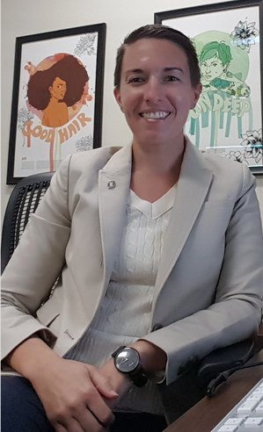
Dr. Jessi Hitchins received her doctorate in Educational Leadership from the University of Alabama where she also received the Qualitative Research Certificate. She is Director of the Gender and Sexuality Resource Center at the University of Nebraska at Omaha.
Hello Jessi! Would you share a little bit about your current position?
I am the Director of the Gender and Sexuality Resource Center at the University of Nebraska Omaha. I have 3 umbrella charges here, as it is a Women and Gender Center, LGBT Center, and Victim and Survivor Advocacy Space. These are closely intertwined. I also work within the subdivision of Inclusion which regards multicultural affairs, accessibility services, and veteran military affairs. We literally are all in the same space. We try to integrate our work and be as accessible to one another as possible.
How do students on campus learn about you?
Students learn about our resources at annual new/transfer-student orientations, including how to have healthy relationships. During Welcome Week, we also have an LGBT social which is part of the Safe Space Program we manage and support. Approximately 200 students go to that.
What was your major program when you were here?
It was social and cultural studies in education, under the umbrella of Educational Leadership.
How did you become aware of the Qualitative Research Certificate at UA?
As part of my course of study, I had to take a qualitative class. My first class was a special offering with Sara Childers on Feminist Policy Analysis. Professors matter, and Dr. Sara Childers allowed me to process pain within my research, and to do so effectively. Thereafter I was hooked. Before it was even available, I started to accumulate the credits to receive the certificate. Conveniently, many of my required Women’s Studies Certificate course requirements also satisfied the Qualitative Research Certificate course requirements.

Did you have a similar experience in the remaining Qualitative Research courses?
The qualitative courses were theoretically-based enabling me a larger understanding of how knowledge is created and disseminated. I think more traditional ways that people sometime see and understand research doesn’t allow for marginalized knowledge to be visible. This thinking pairs nicely with the inclusion and advocacy work I do: my experience as a practitioner shines through my researcher positionality.
Can you tell me if and how you connected your dissertation study with and your work as a practitioner?
Yes, my dissertation was about the gamut of faculty and staff LGBTQ experiences. As a polysexual cis woman myself, I had experienced what I perceived to be discrimination in a lot of complex, nuanced ways – towards myself as well as other colleagues who were in our identity group. Using a material feminist lens, I was able to unpack how I might be reading situations – not necessarily incorrectly – but I needed to think about things in different ways to do better in my own work. And yet I also wanted to understand how we can engage in policy-making that makes our work better. My dissertation led to definitive recommendations for practitioners, academics, and any other full-time university employees who are LGBT.
Are you able to continue this line of work in your current position?
This next year I have a practitioner- and service-oriented fellowship at the university. The year after that, I plan to pick up my dissertation line of research again. I will also have the opportunity teach classes in my university’s sociology department, which currently has a number of quantitative research professors, and is interested in my background in theory and qualitative research.
You had your major disciplinary conference communities, and then there’s the qualitative research (ICQI) community. How do you see the qualitative research community connected to and/or different from your major communities?
I think there’s a one-to-one discussion being had in my professional practitioner communities, which doesn’t challenge me as much as I’d like it to: people seem hung up on particular things that qualitative research demonstrates ebb and flow in the long run. And so I’ve personally decided that I will probably go to ICQI every year because it’s a place where my brain feels alive and energized. The nerd in me wants to be around those nerdy people, to allow the synapsis to fire in the ways that challenge me. I choose which sessions to attend based on my interest in supporting new researchers, an intriguing presentation title, or seeing the academics I follow who make me think in all these weird, cool new ways. I have fan girl moments where I’m like, “yay, this my shero!”
Is there anything you would like to add about your time in your program or your experience, how it’s influencing you now?
What’s really cool is seeing theory I learned in my qualitative courses come to life in the work that we do here. For example, I have the opportunity to challenge voices among those at the university who consider themselves neutral, or do not recognize the power historically assigned to them. My women and nonbinary colleagues also see these thing and we amplify each other’s voices. It’s a powerful thing to navigate.

